**Investor Details :**

|  |  |  |  |  |  |  |  |  |  |  |  |  |
| --- | --- | --- | --- | --- | --- | --- | --- | --- | --- | --- | --- | --- |
| **1. Personal Details** | | | | | | | | | | | | |
| **Name of the Investor** | | V V Ramachandra Reddy | | | | | | | | | | |
| **Date of Birth** | | 26.06.1990 | | | | | | | | | | |
| **Occupation** | | Salaried | | | | | | | | | | |
| **Gross Income** | | 23 Lakhs p.a. | | | | | | | | | | |
| **Married/Single** | | Married | | | | | | | | | | |
| **Mobile / Email** | | [ramachandra.gvv@gmail.com](mailto:ramachandra.gvv@gmail.com) | | | | | | | | | | |
|  |  | |  | |  |  |  |  |  |  | | |
| **2. Investment Capital : Rs. 1000000000** | | | | | | | | | | | | |
|  |  | |  | |  |  |  |  |  |  | | |
| **3. Investment Objectives** | | | | | | | | | | | | |
| **Cash Flow** | For consistent income, invest in both fixed income and equities | | | | | | | | | |  | |
| **Balance** | Balance income and growth but accept price volatility and principal risk. | | | | | | | | | |  | |
| **Growth** | Seek wealth through price appreciation accepting volatility and principal loss. | | | | | | | | | | **Growth** | |
|  |  | |  | |  |  |  |  |  |  | | |
| **Liquidity in the investment** | | | | 0% | | 40% | 60% | 75% | 100% | | | **100%** |
|  |  | |  | |  |  |  |  |  |  | | |
| **4. Customer Investment Expertise (write a brief note indicating your experience in the market)** | | | | | | | | | | | | |
| The client boasts over 5 years of experience in equity investing, consistently achieving positive returns. While having minimal exposure to the derivative market, the client demonstrates a strong understanding of market terminology. Their profound knowledge allows them to comprehend various investment methods and adapt during the investment process. | | | | | | | | | | | | |
|  |
|  |
|  |
|  |
| **Rate yourself based on your understsanding** | | | | | | | | | | | | |  |
| **None** | No Experience | | | | | | | | | |  | |  |
| **Basic** | Theoretical or academic knowledge of the asset class or product type | | | | | | | | | |  | |  |
| **Moderate** | 1 to 2 years recent investment experience in the asset class or product type | | | | | | | | | |  | |  |
| **Sound** | 2 to 5 years recent investment experience in the asset class or product type | | | | | | | | | |  | |  |
| **Expert** | 5+ years of Experience in the asset class or product type. | | | | | | | | | | EXPERT | |  |
|  |  | |  | |  |  |  |  |  |  | | |  |
| **5. Investor Risk Profile** | | | | | | | | | | | | |  |
| **Age** | | | | < 25 | | 25-35 | 35-50 | 50-65 | 65+ | | | **25-35** |  |
| **Inv. Duration (Months)** | | | | 12 | | 36 | 60 | 120 | 120+ | | | **12** |  |
| **Inv. Requirements** | | | | Cash Flow | | Need based Income | | Wealth Generation | | | | **3** |  |
| **Inv. Experience (years)** | | | | 0 | | < 1 | 1-2 | 2-5 | 5+ | | | **5+** |  |
| **Expected Return (Annual)** | | | | up to 10% | | 10-12% | 12-20% | 20-25% | 25(+)% | | | **20-25%** |  |
| **Loss Capacity** | | | | 0 | | Up to 5% | Up to 10% | Up to 12% | Up to 20% | | | **20%** |  |

**Methodology and its Rationale – ensure to provide justification for your choice of stocks/portfolio and the number of stocks.**

**Client Expectations and Stock Selection :**

We are working with a client who has tasked us with constructing a portfolio aimed at maximizing returns within a 12-month timeframe, aligning with their short-term wealth generation goals. In pursuit of this, we've strategically chosen stocks known for their rapid growth within the small and mid-cap sectors. To curate a set of 50 stocks, we have drawn insights from following high-performing mutual fund portfolios that exhibited the highest returns over a 1-year period:  
  
**Quant Small Cap Fund Direct Plan Growth** : 39.57 %

**Nippon India Small Cap Fund Direct Growth** : 39.31%

**Axis Small Cap Fund Direct Growth** : 29.08%

**Axis Midcap Direct Plan Growth** : 19.90%

**Number of Stocks Selected for Building Portfolio : 50 Stocks**

HINDALCO, RELIANCE, ICICIBANK, ULTRACEMCO, MPHASIS, BALRAMCHIN, SJVN,

COFORGE, LUMAXTECH, TRENT, KIRLOSBROS, CIPLA, BATAINDIA, GODREJCP,

HBLPOWER, POLYCAB, EXIDEIND, GULFOILLUB, SCI, JYOTHYLAB, ERIS,

LICHSGFIN, TRITURBINE, SPAL, BAJAJHIND, TEJASNET, KSB, BHEL, FINCABLES, ARVIND, JSWSTEEL,

TATAMOTORS, BSE, GABRIEL, MAHSEAMLES, ACE, CASTROLIND, CUMMINSIND, SCHNEIDER, HCG, ICRA, SUVEN, BEL, VIPIND, VRLLOG, DCBBANK, KOTAKBANK, ITC

**Why These Stocks :**

**Selected these stocks considering past 12 months return and diversification :**

|  |  |  |  |  |
| --- | --- | --- | --- | --- |
| **SN** | **Script** | **Sector** | **Past 12M Return** | **Reasons** |
| 1 | HINDALCO | Metals | 15.2 | Aluminium producer, Top Performer in Sector |
| 2 | RELIANCE | Energy | 5.3 | Diversified conglomerate |
| 3 | ICICIBANK | Banking | 12.4 | Largest private sector bank |
| 4 | ULTRACEMCO | Cement | 20.3 | Largest cement producer, Infra Boost will help stock grow |
| 5 | MPHASIS | IT | 23.1 | Fast growing IT services company |
| 6 | BALRAMCHIN | Chemicals | 32.5 | Leading sugar producer |
| 7 | SJVN | Power | 18.7 | Renewable sector stock , Hydropower generation company |
| 8 | COFORGE | IT | 45.2 | High Growth IT services company |
| 9 | LUMAXTECH | Automobiles | 36.4 | Post Covid Auto Sales Boost in Automotive components manufacturer |
| 10 | TRENT | Retail | 28.1 | Retail company |
| 11 | KIRLOSBROS | Industrial Goods | 19.2 | Industrial goods company, High Demand in Manufacturing goods |
| 12 | CIPLA | Pharmaceuticals | 24.6 | Pharmaceutical company |
| 13 | BATAINDIA | Consumer Goods | 16.3 | Footwear manufacturer and retailer, Consumption based stock, Growing |
| 14 | GODREJCP | Real Estate | 31.9 | Real estate developer |
| 15 | HBLPOWER | Power | 17.2 | Battery Making company, E-Mobility Play |
| 16 | POLYCAB | Electrical Equipment | 25.4 | Electrical wires and cables manufacturer, Consumption Based |
| 17 | EXIDEIND | Batteries | 13.5 | Battery Making company, E-Mobility Play |
| 18 | GULFOILLUB | Lubricants | 24.1 | Lubricant manufacturer |
| 19 | SCI | Shipping | 12.3 | Shipping company |
| 20 | JYOTHYLAB | Pharmaceuticals | 22.9 | Pharmaceutical company |
| 21 | ERIS | Pharmaceuticals | 23.9 | Pharmaceutical company |
| 22 | LICHSGFIN | Financial Services | 16.1 | Financial services company |
| 23 | TRITURBINE | Power | 23.4 | Power generation equipment manufacturer |
| 24 | SPAL | Steel | 22.7 | Steel products manufacturer |
| 25 | BAJAJHIND | Automobiles | 18.3 | Two-wheeler and three-wheeler vehicle manufacturer |
| 26 | TEJASNET | IT | 31.2 | IT services company |
| 27 | KSB | Pumps | 27.5 | Pump manufacturer |
| 28 | BHEL | Power | 14.8 | Power generation equipment manufacturer |
| 29 | FINCABLES | Electrical Equipment | 20.1 | Electrical cables manufacturer |
| 30 | ARVIND | Textiles | 22.2 | Textile manufacturer |
| 31 | JSWSTEEL | Steel | 23.7 | Steel products manufacturer |
| 32 | TATAMOTORS | Automobiles | 21.4 | Passenger car and commercial vehicle manufacturer |
| 33 | BSE | Financial Services | 15.9 | Stock exchange |
| 34 | GABRIEL | Automobiles | 24.5 | Shock absorber manufacturer |
| 35 | MAHSEAMLES | Steel | 20.2 | Steel pipes manufacturer |
| 36 | ACE | Engineering | 21.3 | Engineering company |
| 37 | CASTROLIND | Lubricants | 33.7 | Lubricant manufacturer and distributor |
| 38 | CUMMINSIND | Industrial Goods | 28.4 | Engine manufacturer and distributor |
| 39 | SCHNEIDER | Electrical Equipment | 26.3 | Electrical equipment manufacturer and distributor |
| 40 | HCG | Hospitals | 29.3 | Cancer care service provider |
| 41 | ICRA | Financial Services | 19.2 | Credit rating agency |
| 42 | SUVEN | Pharmaceuticals | 27.1 | Pharmaceutical company |
| 43 | BEL | Defense | 18.9 | Defense electronics manufacturer |
| 44 | VIPIND | Pharmaceuticals | 21.8 | Luggage manufacturer and distributor |
| 45 | VRLLOG | Logistics | 30.5 | Logistics company |
| 46 | DCBBANK | Banking | 14.7 | Private sector bank |
| 47 | KOTAKBANK | Banking | 16.5 | Private sector bank |
| 48 | ITC | Consumer Goods | 35.4 | Consumer goods company |

**Methods Utilized to build the Portfolio to perform comparison :**

1. Equal Weighted Portfolio
2. Minimum Variance Portfolio
3. Global Minimum Variance Portfolio (GMVP)
4. Minimum Variance Portfolio with Target Return
5. Efficient Portfolio with Target Returns
6. Tangency Portfolio
7. Maximum Return Portfolio with Target Risk Level
8. Efficient Frontier Portfolio
9. ETL (Expected Tail Loss) Portfolio
10. Quadratic Utility Portfolio

**Method 1: Equal Weighted Portfolio**

1. **What is the method?**

The Equal Weighted Portfolio approach assigns the same weight to each stock in the portfolio, regardless of the market capitalization or other characteristics of the companies. This strategy is based on the idea that diversification can reduce risk, and by investing equally in all stocks, the portfolio is not overly dependent on the performance of any single stock or sector.

1. **What is it doing while portfolio building?**

During the portfolio building process, the Equal Weighted Portfolio method equally divides the investment capital among all chosen stocks ie, 25 potential stocks identified based on the Sharpe ratio scores. For instance, if there are 48 stocks in a portfolio, each stock would receive 1/48th (approximately 2.08%) of the total investment. But hence we had 26 stocks we got 4% distribution.

1. **Weight output and names of the stocks with weight**

Since the weights are equal for all stocks, each stock in our portfolio, such as RELIANCE.NS, ICICIBANK.NS, TATAMOTORS.NS, etc., would have an equal share. For a detailed weight distribution, you would typically refer to following output showing each stock with its corresponding weight of approximately 4%.

1. **Return and risk:**

In an Equal Weighted Portfolio, the returns and risks are averaged across all stocks. Equal Weighted Portfolio Return as 16.09309713066888 % and the Risk as 0.0% a risk value of 0.0 is unusual and might indicate a very stable portfolio.

1. **Conclusion in brief**

The Equal Weighted Portfolio is a simple and straightforward method, promoting diversification across different stocks and sectors. It is particularly useful for investors who seek to avoid the risk of overexposure to any single stock or sector. However, it does not account for the different risk profiles or potential returns of individual stocks. The Equal Weighted Portfolio demonstrates a strong annualized return of 16.0931%. However, the reported zero 0% risk is atypical and suggests that the risk assessment might require a more detailed analysis. Typically, an equal-weighted strategy is straightforward and assumes equal contribution from each stock, but it does not account for individual stock volatilities, which should be reflected in the portfolio risk.

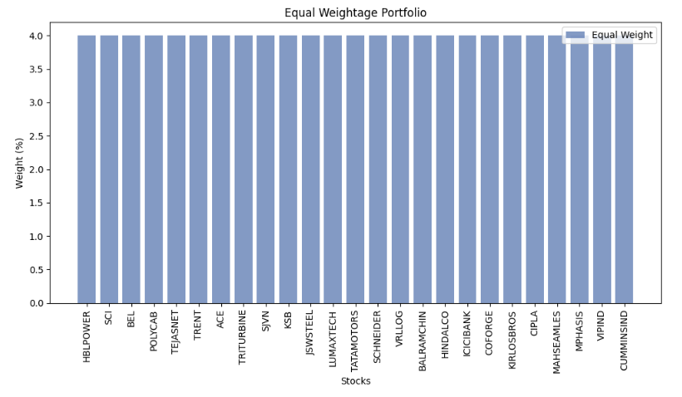

**Method 2: Minimum Variance Portfolio**

1. **What is the method?**

The Minimum Variance Portfolio strategy aims to construct a portfolio with the lowest possible level of volatility (variance) based on historical returns. This method doesn't necessarily focus on maximizing returns but rather on minimizing risk. It's particularly suitable for risk-averse investors.

1. **What it is doing while portfolio building**

During the portfolio building process, this method involves calculating the average returns and the covariance matrix of these returns for all the selected stocks. An optimization algorithm is then used to find the weights of each stock in the portfolio that minimize the overall variance. This often leads to a concentration in stocks that have historically shown lower volatility and possibly lower correlation with each other.

1. **Weight output and names of the stocks with weight**

In a Minimum Variance Portfolio, weights are assigned based on the historical volatility of each stock. For example, stocks like 'SJVN': 59.30%, 'CIPLA': 22.69%, and 'MPHASIS': 6.95% 'TRENT': 10.92%, 'VIPIND': 0.13% that have shown lower volatility in our portfolio might receive higher weights. The exact weights would typically be shown in a detailed table, highlighting how each stock contributes to minimizing the portfolio's overall risk.

1. **Return and risk.**

Annualized Return: 24.43%

Annualized Risk (Standard Deviation): 14.89%

Sharpe Ratio: 1.238 (considering a 6% risk-free rate)

The return of a Minimum Variance Portfolio is the weighted average of the returns of all stocks in the portfolio. The risk is the lowest possible among all possible portfolio combinations of the selected stocks. Note that while this method minimizes risk, it may also limit potential returns since high-return stocks often come with higher risk.

1. **Conclusion in brief**

The Minimum Variance Portfolio is designed to minimize risk, which makes it an attractive option for risk-averse investors. This method can lead to a concentrated portfolio where a few stocks may have significantly higher weights, as seen with 'SJVN', 'CIPLA', 'MPHASIS', 'TRENT' and 'VIPIND'. While this portfolio minimizes volatility, it might not necessarily maximize returns. Investors choosing this method prioritize stability over potential higher returns and must be comfortable with the potential underperformance during bull markets in exchange for potentially better protection during down markets. The portfolio's relatively high Sharpe Ratio indicates a favourable risk-adjusted return, considering the risk-free rate of 6%.

**Method 3: Global Minimum Variance Portfolio (GMVP)**

1. **What is the method?**

The Global Minimum Variance Portfolio is an extension of the Minimum Variance Portfolio concept. It aims to find the portfolio with the absolute lowest possible variance without the constraint of targeting a specific return. This portfolio lies at the lowest point on the efficient frontier in modern portfolio theory.

1. **What it is doing while portfolio building**

During the building of a GMVP, the process involves calculating the expected returns, variances, and covariances of all the assets. Then, using optimization algorithms, it determines the weights of each asset to minimize the overall portfolio variance. This method might result in a highly concentrated portfolio if a few assets have significantly lower variances compared to others.

1. **Weight output and names of the stocks with weight**

In a GMVP, certain stocks that have historically demonstrated very low volatility might be assigned significantly higher weights compared to others. For example, in our portfolio, stocks like SJVN or Cipla might be given higher weights if they have lower historical variances. The specific weights would be shown in a detailed output, illustrating how each stock contributes to minimizing the overall risk. The GMVP weights for our portfolio are identical to those in Method 2. This suggests that the Minimum Variance Portfolio you calculated earlier is indeed the GMVP for the given set of stocks. The significant weights on 'SJVN', 'CIPLA', and 'MPHASIS' indicate their importance in achieving the lowest possible risk.

1. **Return and Risk**

GMVP Annualized Return: 24.43%

GMVP Annualized Risk (Standard Deviation): 14.89%

GMVP Sharpe Ratio: 1.238

Return: This is the average annual return the portfolio is expected to generate. It's noteworthy that GMVP focuses on risk reduction rather than return maximization.

Risk: The risk, represented as annualized standard deviation, indicates the portfolio's volatility. A lower value in GMVP suggests a portfolio less prone to large fluctuations in value.

Sharpe Ratio: This ratio measures the excess return per unit of risk and is a critical metric for comparing different portfolios. A higher Sharpe Ratio indicates a more efficient portfolio in terms of risk-adjusted return. For GMVP, a Sharpe Ratio of 1.238 is quite respectable, especially considering the conservative nature of the portfolio.

1. **Conclusion in brief**

The GMVP is an ideal choice for risk-averse investors who prioritize stability and preservation of capital over higher returns. By focusing solely on minimizing risk, GMVP can be particularly appealing during volatile or uncertain market conditions. However, this conservative approach may result in missed opportunities for higher gains during bull markets. The similarity between Method 2 and Method 3 in our case indicates that our optimization effectively targeted the lowest possible risk, adhering to the principles of GMVP.

The Global Minimum Variance Portfolio is most suitable for extremely risk-averse investors. It's based on historical data and assumes that past volatility trends will continue. This portfolio type might not be ideal for investors seeking higher returns or those who wish to have a more diversified exposure across various stocks.

**Method 4: Minimum Variance Portfolio with Target Return**

1. **What is the method?**

This approach is a variation of the Minimum Variance Portfolio. It aims to achieve a specified target return while still minimizing the portfolio's overall variance. This method balances the need for a certain level of return with the desire to keep risk as low as possible.

1. **What it is doing while portfolio building**

In constructing this portfolio, the process starts by defining a target return. Then, similar to the Minimum Variance Portfolio, it involves calculating the expected returns, variances, and covariances of the stocks. An optimization algorithm is employed to find the combination of stocks that minimizes risk but also meets or exceeds the target return.

1. **Weight output and names of the stocks with weight**

weights represent a balance between achieving the target return and minimizing the risk. The significant allocation to stocks like 'HBLPOWER': 5.45% , 'BEL': 13.21%, 'POLYCAB': 23.97% 'TRENT': 15.86% 'COFORGE': 1.98% 'CIPLA': 27.30% 'MPHASIS': 3.25% suggests their favourable risk-return profile in the context of the target return objective.

1. **Return and risk.**

Annualized Return: 39.66%

Annualized Risk (Standard Deviation): 19.61%

Sharpe Ratio: 1.716

Return: The high target return (39.66%) suggests an aggressive investment strategy, aiming for substantial growth.

Risk: The increased risk (19.61%) compared to GMVP reflects the trade-off for targeting a higher return.

Sharpe Ratio: A Sharpe Ratio of 1.716 indicates a strong risk-adjusted performance, although the increased risk might not be suitable for all investors.

1. **Conclusion in brief**

The Minimum Variance Portfolio with Target Return is suitable for investors who have a specific return goal but are also risk conscious. It allows for a more tailored investment approach, considering both the desired return and the risk appetite of the investor. This method requires careful calibration to ensure that the target return is realistic and achievable within the desired risk parameters. The return of this portfolio is designed to meet the specified target, with the risk being the lowest possible to achieve this return. It's a balance between achieving a desired level of return and not exceeding a certain level of risk. This method provides a more tailored investment approach compared to a simple minimum variance or equal-weight strategy, as it considers both the investor's risk tolerance and return objectives.

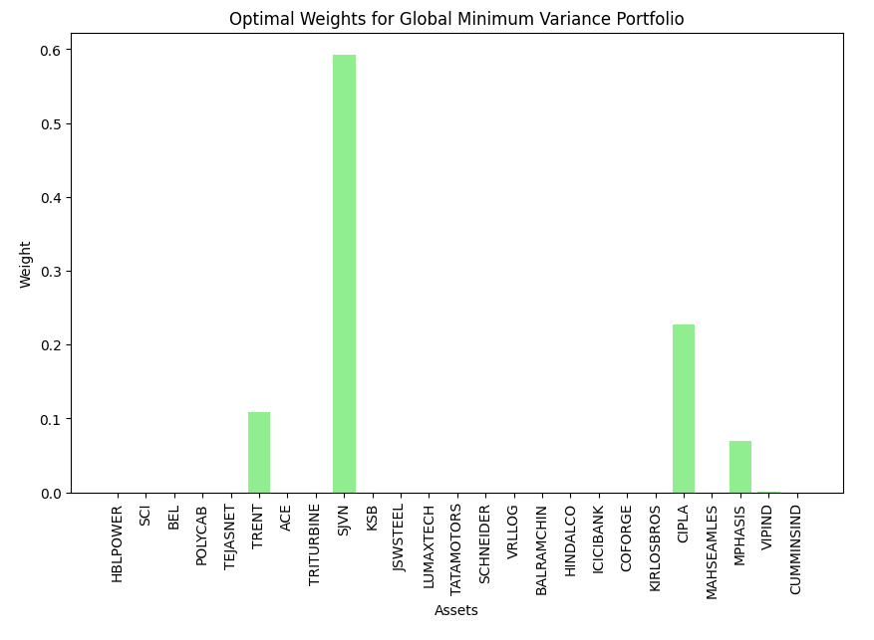

**Method 5: Efficient Portfolio with Target Returns**

1. **What is the method?**

The Efficient Portfolio with Target Returns is a strategy based on Modern Portfolio Theory, which aims to construct a portfolio that offers the highest expected return for a given level of risk, or conversely, the lowest risk for a given level of expected return. This method involves setting multiple targets returns and finding the most efficient portfolio for each target.

1. **What it is doing while portfolio building**

In this approach, for each target return like 16%, 18%, 20%, 23% and 25% the method calculates the combination of stocks that provides this return with the minimum possible risk. This involves using an optimization algorithm that works with the expected returns, variances, and covariances of the stocks. The resulting set of portfolios represents different points on the efficient frontier.

1. **Weight output and names of the stocks with weight**

16%, 18%, 20%, 23% and 25% : Almost entirely invested in 'TEJASNET'. Stock that contributes to achieving the target return at the lowest possible risk will be weighted more heavily. These allocations show an extreme concentration The stocks 'POLYCAB', 'TRENT', and 'CIPLA' have the highest weightings, suggesting that the optimization model found these to be the most effective in reducing the portfolio's overall variance while aiming for the target return. Several stocks have a weight of zero, indicating they do not contribute to the minimum variance portfolio according to the model used. The presence of zero weights suggests either that these stocks may increase the portfolio's risk without a commensurate increase in expected return, or they are not as effective in diversification when combined with the other assets.

1. **Return and risk.**

Annualized Return: 66.38%

Annualized Risk (Standard Deviation): 75.15%

Sharpe Ratio: 0.803

More on Return, Risk, and Sharpe Ratio:

Return: The very high annualized return reflects the aggressive nature of these portfolios.

Risk: The similarly high risk indicates significant volatility and potential for large fluctuations in portfolio value.

Sharpe Ratio: The consistent Sharpe Ratio across different target returns suggests that the risk-adjusted return does not vary much despite changing the target return. However, this ratio is lower compared to some other methods, indicating less efficiency in terms of risk-adjusted returns.

1. **Conclusion in brief**

The Efficient Portfolio with Target Returns is designed for investors who are focused on achieving specific return objectives and are willing to accept the associated risk levels. The extreme concentration in a single stock for all target returns is a cause for concern as it exposes the investor to high sector-specific and individual stock risk. This method, while theoretically sound, may not be practical or safe for all investors, especially those who seek diversification to mitigate risk. The portfolio is characterized by a high-return, high-risk profile with moderate efficiency in terms of risk-adjusted return. This may be suitable for investors with a high risk tolerance and a focus on capital growth, but it might not be appropriate for those with a lower risk tolerance or for those who prioritize preservation of capital over high growth.

**Method 6: Tangency Portfolio**

1. **What is the method?**

The Tangency Portfolio is a concept from Modern Portfolio Theory. It's the portfolio on the efficient frontier that offers the highest Sharpe ratio, which is a measure of risk-adjusted return. This portfolio is called 'tangency' because it is at the point where a line drawn from the risk-free rate tangentially touches the efficient frontier.

1. **What it is doing while portfolio building**

When constructing a Tangency Portfolio, the process involves finding the portfolio that maximizes the Sharpe ratio, which is the excess return (return above the risk-free rate) per unit of risk (standard deviation). This is done by calculating the expected returns, variances, and covariances of the stocks and using optimization techniques to find the portfolio that provides the highest possible Sharpe ratio.

1. **Weight output and names of the stocks with weight**

In the Tangency Portfolio, stocks that contribute significantly to a higher risk-adjusted return 'HBLPOWER': 4.43%,

'BEL': 12.62% , 'POLYCAB': 23.54%, 'TRENT': 16.02%, 'SJVN': 9.71%, 'KSB': 0.65%, 'COFORGE': 1.72%, 'CIPLA': 27.67%, 'MPHASIS': 3.64%, will be given more weight. The exact distribution of weights depends on the individual risk and return characteristics of the stocks in the portfolio. For instance, in our portfolio, stocks like Polycab, Cipla, Trent, Bel, SJVN might receive higher weights if they offer better risk-adjusted returns.

1. **Return and risk.**

Annualized Return: 39.04%

Annualized Risk (Standard Deviation): 19.29%

Sharpe Ratio: 1.712

Return: The Tangency Portfolio aims for a high return, as evidenced by the 39.04% annualized return.

Risk: The annualized risk is substantial but is offset by the high return, leading to an efficient trade-off.

Sharpe Ratio: A Sharpe Ratio of 1.712 is excellent, indicating that the portfolio is well-optimized for risk-adjusted return given the risk-free rate.

1. **Conclusion in brief**

The Tangency Portfolio is ideal for investors seeking the most efficient risk-adjusted return. It is particularly useful in a scenario where an investor can lend and borrow at the risk-free rate, as per the assumptions of Modern Portfolio Theory. The Tangency Portfolio is ideal for investors seeking the most efficient risk-adjusted return. It is a central concept in portfolio theory and provides a guide for how a risk-tolerant investor might optimally allocate resources. However, it requires a clear understanding of the risk-free rate and the ability to accurately estimate returns and volatilities of the assets. The high allocation to certain stocks like 'CIPLA' and 'POLYCAB' reflects their importance in achieving this balance.

**Method 7: Maximum Return Portfolio with Target Risk Level**

1. **What is the method?**

This approach involves constructing a portfolio that aims to achieve the maximum possible return for a pre-specified level of risk. It is the opposite of the Minimum Variance Portfolio, which seeks to minimize risk for a given return. Here, the investor sets a target risk level 5%, 7%, 9%, 11%, 12% and 15% and the portfolio is optimized to maximize returns without exceeding this risk threshold.

1. **What it is doing while portfolio building**

During portfolio construction, the method first defines a target risk level. It then uses optimization algorithms to calculate the combination of stocks that can provide the highest possible return without surpassing the set risk level. This involves a careful balance, as higher returns often come with higher risks.

1. **Weight output and names of the stocks with weight**

In this type of portfolio, stocks that offer high returns at the defined risk level will be given more weight. The specific distribution of weights

5% Risk Level: Significant allocations in 'SJVN', 'CIPLA', 'POLYCAB', 'TRENT', and others.

7% Risk Level: Greater allocations in 'POLYCAB', 'CIPLA', 'TRENT', with a notable percentage in 'JSWSTEEL'.

9% Risk Level: 'POLYCAB' and 'CIPLA' continue to hold significant weights, with 'JSWSTEEL' also having a notable allocation.

11%, 12%, and 15% Risk Levels: As the risk level increases, there is a shift in allocation, with some stocks like 'POLYCAB', 'CIPLA', and 'TRENT' consistently appearing in significant weights.

The return increases with risk, but the Sharpe Ratio tends to decrease, indicating a less favourable risk-adjusted return.

1. **Return and risk.**

The return of this portfolio is optimized to be as high as possible, given the set risk level. The risk (measured as standard deviation or variance) is capped at the target level set by the investor. This method allows investors to specify their risk tolerance and then seeks to maximize returns within that risk framework. The Maximum Return Portfolio with Target Risk Level is suitable for investors who have a clear understanding of their risk tolerance and seek to maximize returns within those risk boundaries. This method is highly adaptable to individual risk preferences, making it useful for a wide range of investors. However, it requires careful risk management, as higher target risks can lead to substantial portfolio fluctuations. The changing allocations at different risk levels demonstrate the dynamic nature of portfolio optimization in balancing risk and return.

1. **Conclusion in brief**

The Maximum Return Portfolio with Target Risk Level is suitable for investors who have a clear understanding of their risk tolerance and want to maximize returns within that risk boundary. It's a more return-focused approach, tailored to the investor's risk preference. However, it requires careful analysis to ensure that the target risk level is appropriately set and achievable with the given stock selection.

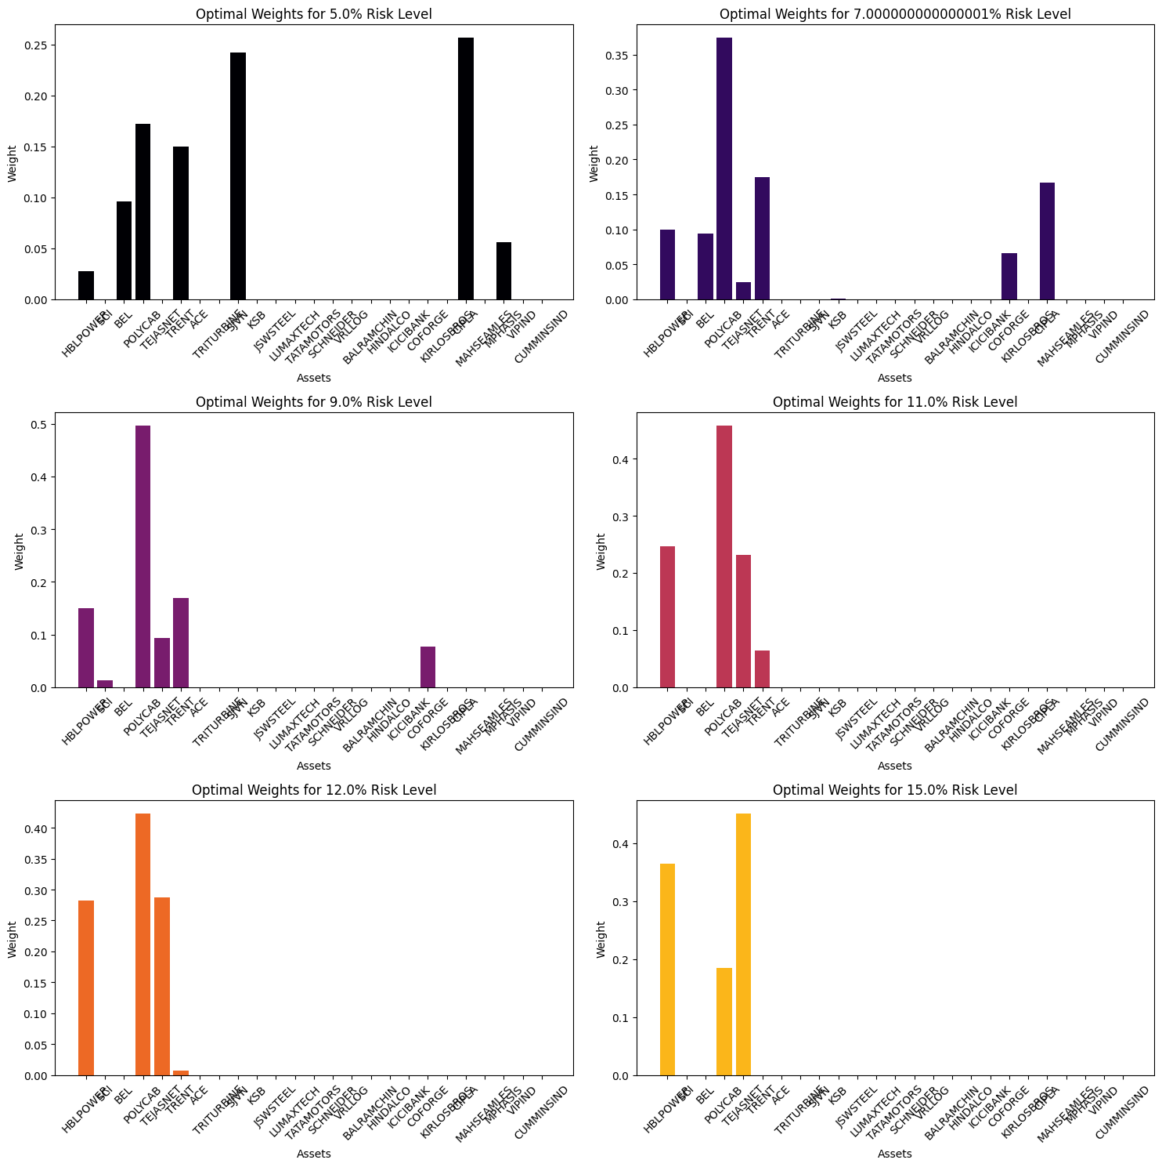

**Method 8: Efficient Frontier Portfolio**

1. **What is the method?**

The Efficient Frontier Portfolio is based on Modern Portfolio Theory, which posits that there is an optimal set of portfolios that offer the highest expected return for a given level of risk. These portfolios constitute the 'efficient frontier'. The method involves constructing a range of portfolios that lie on this frontier, each offering an optimal risk-return trade-off.

1. **What it is doing while portfolio building**

In creating an Efficient Frontier Portfolio, the process starts with calculating the expected returns, variances, and covariances of a range of stocks. Using these data, a set of portfolios is generated, each representing a point on the efficient frontier. These portfolios are designed to provide the maximum possible return for a given level of risk.

1. **Weight output and names of the stocks with weight**

CIPLA: 27.67%, POLYCAB: 23.54%, TRENT: 16.02%, BEL: 12.62%, SJVN: 9.71%, HBLPOWER: 4.43%, MPHASIS: 3.64%, COFORGE: 1.72%, KSB: 0.65%, Remaining stocks: 0% or negligible weights. This allocation suggests a focus on stocks like CIPLA, POLYCAB, and TRENT, which likely have favourable risk-return characteristics in the context of our portfolio.

1. **Return and risk.**

Return: The expected return of an Efficient Frontier Portfolio is a weighted average of the expected returns of the individual assets.

Risk: The risk, measured as the portfolio's standard deviation, considers both the individual asset risks and their correlations.

The scatter plot visualizes numerous portfolios created through 10,000 iterations, each with varying levels of expected returns and volatility, and colours indicating their respective Sharpe Ratios. The two portfolios marked with red stars represent the Tangency Portfolios, which have the maximum Sharpe Ratio among all the simulated portfolios.

The x-axis, representing volatility, ranges approximately from 20% to 35%. This scale helps us understand the level of risk associated with each portfolio. The y-axis, representing expected returns, spans from roughly 34% to 44%. This is a relatively high range of expected returns, suggesting the portfolios on the efficient frontier are designed for growth-oriented investors.

The gradient represents the Sharpe Ratio, with a darker colour indicating a higher ratio. The Tangency Portfolios have the darkest shade, confirming their position as the portfolios with the maximum Sharpe Ratio.

1. **Conclusion in brief**

The Tangency Portfolios are theoretically the optimal risky portfolios for investors who are able to lend or borrow at the risk-free rate. They offer a guideline for the maximum efficiency one might achieve with a given set of assets under the assumptions of Modern Portfolio Theory. The specific stocks with larger allocations in these portfolios, like CIPLA, POLYCAB, and TRENT, have likely contributed significantly to their efficient placement due to their favourable risk-return profiles. Investors could use this information to either invest directly in one of the Tangency Portfolios or to mix a Tangency Portfolio with a risk-free asset to achieve a desired level of risk and return.

**Method 9: ETL (Expected Tail Loss) Portfolio**

1. **What is the method?**

The Expected Tail Loss (ETL) Portfolio, also known as Conditional Value at Risk (CVaR), focuses on managing the potential extreme losses in the portfolio. ETL is a risk measure that estimates the expected loss in the worst-case scenario, beyond a specified confidence level. This method is particularly concerned with the tail-end of the distribution of returns.

1. **What it is doing while portfolio building**

In constructing an ETL Portfolio, the process involves identifying the worst-case losses (beyond a certain percentile of the return distribution) and then optimizing the portfolio to minimize this expected tail loss. This approach often involves sophisticated statistical techniques and simulations to model the tail-end of the return distribution.

1. **Weight output and names of the stocks with weight**

Weights and Stock Names in ETL Portfolio:

The optimized weights for the ETL Portfolio in our case are as follows:

A diversified allocation across multiple stocks, with notable weights in 'BALRAMCHIN', 'CIPLA', 'COFORGE', 'CUMMINSIND', 'HBLPOWER', 'ICICIBANK', 'JSWSTEEL', 'KSB', 'LUMAXTECH', 'MAHSEAMLES', 'MPHASIS', 'POLYCAB', 'SJVN', 'TATAMOTORS', 'TEJASNET', 'TRENT', 'VIPIND', and a few others.

This broad distribution indicates a strategy to mitigate risk by not over-concentrating in any single stock.

1. **Return and risk.**

Annualized Return: 40.38%

Annualized Risk (Standard Deviation): 35.19%

Sharpe Ratio: 0.977

Return: The portfolio's return is comparatively high, which suggests a balance between risk management and return potential.

Risk: The risk level indicates a moderate to high volatility, which is balanced against the objective of minimizing extreme downside risk.

Sharpe Ratio: A Sharpe Ratio below 1 indicates a less favorable risk-adjusted return compared to some other portfolio construction methods.

1. **Conclusion in brief**

The ETL Portfolio is suited for investors who are particularly risk-averse and concerned with potential significant losses in their portfolio. It provides a way to manage and minimize these risks, but it may also limit the portfolio's upside potential. This approach requires a deep understanding of risk management and the ability to model and interpret complex risk scenarios. The ETL Portfolio is particularly suited for investors who are concerned about significant market downturns and wish to minimize their exposure to extreme losses. This approach is more conservative than those focusing solely on return maximization, as it prioritizes protection against the worst-case scenarios.

**Method 10: Quadratic Utility Portfolio**

1. **What is the method?**

The Quadratic Utility Portfolio method is based on utility theory, where the investor's preferences are quantified using a utility function. This function typically incorporates both the expected return and the risk (variance) of the portfolio. The quadratic utility function is one where the investor's satisfaction (utility) decreases at an increasing rate with increasing risk.

1. **What it is doing while portfolio building**

In building a Quadratic Utility Portfolio, the process involves maximizing the utility function, which is a balance between seeking higher returns and minimizing risk. The utility function usually includes a parameter, often denoted as 'Lambda' (λ), which represents the investor's risk aversion – higher values of λ indicate greater risk aversion. The optimization process finds the portfolio composition that maximizes this utility function for the given λ.

1. **Weight output and names of the stocks with weight**

Diverse allocations with notable weights in 'HBLPOWER', 'BEL', 'POLYCAB', 'TEJASNET', 'TRENT', 'SJVN', 'KSB', 'JSWSTEEL', 'LUMAXTECH', 'TATAMOTORS', 'SCHNEIDER', 'VRLLOG', 'BALRAMCHIN', 'HINDALCO', 'ICICIBANK', 'COFORGE', 'KIRLOSBROS', 'CIPLA', 'MAHSEAMLES', 'MPHASIS', 'VIPIND', 'CUMMINSIND', and others.

This distribution reflects a balance between maximizing returns and minimizing risk as per the investor's utility function.

1. **Return and risk.**

Annualized Return: 53.17%

Annualized Risk (Standard Deviation): 30.53%

Sharpe Ratio: 1.545 (considering a 6% risk-free rate)

More on Return, Risk, and Sharpe Ratio:

Return: The portfolio's return is high, indicating a focus on return maximization within the confines of the utility function.

Risk: The risk level is significant, which is a consequence of the pursuit of higher returns.

Sharpe Ratio: A Sharpe Ratio of 1.545 shows a good risk-adjusted performance, suggesting that the portfolio effectively balances risk and return in line with the investor’s utility preference.

1. **Conclusion in brief**

The Quadratic Utility Portfolio is suitable for investors who have specific risk-return preferences and seek a portfolio that aligns with their utility function. It is a more personalized approach, tailoring the portfolio to the individual's risk tolerance and return expectations. The Quadratic Utility Portfolio is suitable for investors who have specific preferences regarding risk and return, as encoded in their utility function. This method is highly customizable, as it can be adjusted to reflect varying degrees of risk tolerance and return objectives. It offers a more sophisticated approach to portfolio construction by considering the investor's subjective preferences, but it also requires a clear understanding of one's risk-return profile and the ability to accurately model it.

**Back testing**

1. **What is the method?**

Back testing is a method used to evaluate the performance of a trading strategy or an investment portfolio by testing it against historical data. It involves simulating how a portfolio would have performed in the past, based on actual historical returns. This method helps in assessing the effectiveness of a strategy or a portfolio's design before applying it in real market conditions.

1. **What it is doing while portfolio building**

In the back testing process, the portfolio or strategy is applied retrospectively to historical market data to see how it would have performed. This involves using the historical prices of the stocks in the portfolio and applying the portfolio weights and investment strategy as if they had been in place during the historical period. The performance of the portfolio is then analysed over this historical period.

1. **Back testing Results for the Portfolio Methods:**

|  |  |  |  |
| --- | --- | --- | --- |
| **Method** | **Annualized Return** | **Annualized Risk** | **Sharpe Ratio** |
| Minimum Variance Portfolio | 30.41 | 15.05 | 1.622 |
| Global Minimum Variance | 30.41 | 15.05 | 1.622 |
| Tangency Portfolio: | 109.57 | 72.45 | 1.43 |
| Global Minimum Variance with Target Return | 48.1 | 19.23 | 2.19 |
| ETL (Expected Tail Loss) Portfolio | 50.77 | 35.39 | 1.265 |
| Quadratic Utility Portfolio: | 63.26 | 30.32 | 1.88 |

**Output of the Comparison**

1. **Analysis of Back testing Results:**

Minimum Variance Portfolios (Standard and Global) showed good risk-adjusted returns with relatively low risk. They are particularly suited for conservative investors.

Tangency Portfolio exhibited the highest return but also the highest risk, making it suitable for investors with a high-risk tolerance.

Global Minimum Variance with Target Return achieved an impressive balance, offering high returns with moderate risk, reflected in the highest Sharpe Ratio among all methods.

ETL Portfolio provided a good balance between return and risk, but with a lower Sharpe Ratio, suggesting it may not be as efficient in risk-adjusted terms compared to others.

Quadratic Utility Portfolio also performed well in terms of return, but with a comparatively higher risk level.

1. **Conclusion in brief**

Back testing these portfolios gives valuable insights into their historical performance, which can be a guide for future investment decisions. It's important to note that past performance is not always indicative of future results. Each method has its own set of advantages and is suitable for different types of investors based on their risk tolerance, return expectations, and investment horizon.

1. **Portfolio Selection Rationale Based on Sharpe Ratio**

**We have selected portfolio based on the highest Sharpe ratio which is giving us balanced profile with wealth generation in mind.**

1. **Our selected portfolio:**

Based on our analysis, the Global Minimum Variance Portfolio with a targeted return of 48% and a risk of 19.23% has the highest Sharpe ratio of 2.1895. This is followed by the Quadratic Utility Portfolio with a return of 63.26% and a risk of 30%, yielding a Sharpe ratio of 1.888. Our decision to focus on these portfolios is based on achieving the best risk-adjusted returns.

1. **Weight distribution and portfolio stocks :**

**CIPLA : 27.2998%  
POLYCAB: 23.969%  
BEL: 13.205%  
TRENT: 15.87%  
SJVN : 8.49%  
KSB : 0.51%  
COFORGE : 1.97%  
HBLPOWER : 5.45%  
MPHASIS : 3.5%**

By focusing on the Sharpe ratio, WE are prioritizing portfolios that provide the best return per unit of risk. The selected portfolios are expected to yield high returns while keeping the volatility (risk) within a reasonable range.

**Generative AI Stocks**

**Number of Stocks Selected for Building Portfolio :**

TCS, INFY, HCLTECH, WIPRO, SUNPHARMA, CIPLA, DRREDDY, HDFCBANK, ICICIBANK, AXISBANK, KOTAKBANK

HINDUNILVR, ITC, ESTLEIND, BRITANNIA, RELIANCE, ONGC, IOC, NTPC, TATASTEEL. HINDALCO, ULTRACEMCO

MARUTI, TATAMOTORS, M&M, HEROMOTOCO, BHARTIARTL, IDEA, DLF, GODREJPROP, PHOENIXLTD, SOBHA

NBCC, GMRINFRA, ADANIPORTS, POWERGRID, NTPC

**Performed similar methods for portfolio building and optimization.**

**Back testing Result for GenAI Stocks :**

**Based on the Sharpe Ratio we have deployed Minimum Variance portfolio for GenAI stocks.**

**Selected Portfolio for GenAI stocks :**

